# Molecular Geometry

Troy University Chemistry Faculty

[Creative Commons License](http://creativecommons.org/licenses/by-sa/4.0/) Licensed under a [Creative Commons Attribution-ShareAlike 4.0 International License](http://creativecommons.org/licenses/by-sa/4.0/).

Chemists can look at the formula of a simple compound and picture the compound in their minds. This ability is developed by making and examining models. This lab project will help you develop this ability. You will start by drawing a Lewis structure of a species, then make a model of it, and finally decide if the molecule is polar.

Read the material in chapter 9 of your chemistry textbook about bonding and geometry before doing this experiment. **Bring** **your textbook to the lab for this experiment.**

## Procedure

For each species in the following table, give the number of valence electrons in the species, draw the Lewis structure, and give the names of the electronic and molecular geometry of each species. Also, construct a model of each species and draw a sketch of the model.

Your sketches should have bonds in the plane of the paper drawn as plain lines, bonds coming out of the paper drawn as wedges, and bonds going behind the paper drawn as dashes. For example, CH4 could be drawn like this:

C

H

H

H

H

Your sketches may include or exclude double and triple bonds, as you choose. However, please omit lone electrons. Obtain your instructor’s signature on the lab pages before turning in the lab. The instructor will not sign the pages unless he or she has observed that the models were actually made.

**Molecular Shape**

|  |  |  |  |
| --- | --- | --- | --- |
| **Number of**  **Electron Domains** | **Number of**  **Lone Pairs** | **Electronic Geometry** | **Molecular Geometry** |
| 1 | 0 | linear | linear |
| 2 | 0 | linear | linear |
| 3 | 0 | trigonal planar | trigonal planar |
| 3 | 1 | trigonal planar | bent (angular) |
| 4 | 0 | tetrahedral | tetrahedral |
| 4 | 1 | tetrahedral | trigonal pyramidal |
| 4 | 2 | tetrahedral | bent |
| 5 | 0 | trigonal bipyramidal | trigonal bipyramidal |
| 5 | 1 | trigonal bipyramidal | see-saw |
| 5 | 2 | trigonal bipyramidal | T-shaped |
| 5 | 3 | trigonal bipyramidal | linear |
| 6 | 0 | octahedral | octahedral |
| 6 | 1 | octahedral | square pyramidal |
| 6 | 2 | octahedral | square planar |

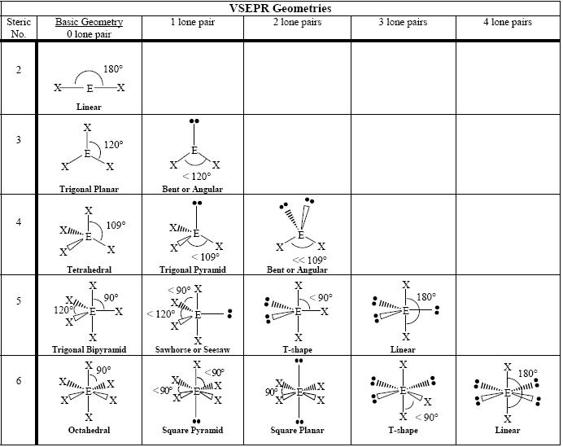

From https://commons.wikimedia.org/wiki/File:VSEPR_geometries.PNG